1. Sales over Month (line chart), Sales by Region (bar chart), and Sales by Category (donut chart)

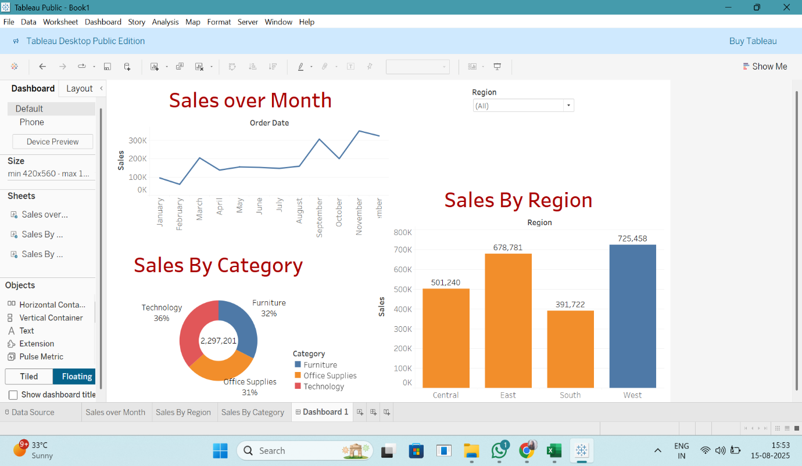

Dashboard Insights

1. Upward Sales Momentum with Seasonal Spikes  
   The line chart reveals a strong upward trend through the year, peaking in September and November. These months likely correspond to high-demand periods (e.g., back-to-school, holiday seasons) and could be prime opportunities for targeted promotions.
2. Region-Wise Performance Highlights
   * West region leads in sales with ~725K
   * East follows with ~679K
   * Central (~501K) and South (~392K) lag behind  
     This shows a clear regional disparity—West and East are dominant. Strategically focusing on Central and South may unlock new growth opportunities.
3. Category Distribution Reveals Balanced Portfolio  
   The donut chart shows a relatively even split across categories:
   * Technology: 36%
   * Furniture: 32%
   * Office Supplies: 31%  
     This balanced distribution suggests solid demand across categories. With Technology holding a slight edge, consider expanding tech offerings while also strengthening promotions for Furniture and Office Supplies to maintain equilibrium.
4. Effective Use of Central KPI Display  
   The total sales figure (₹2,297,201) showcased in the donut’s center delivers immediate impact and context—excellent for KPI-focused storytelling. It helps viewers quickly orient around the dashboard’s scale and performance.

2. Sales over Month (line chart), Sales by Region (bar chart), and Sales by Category (donut chart)

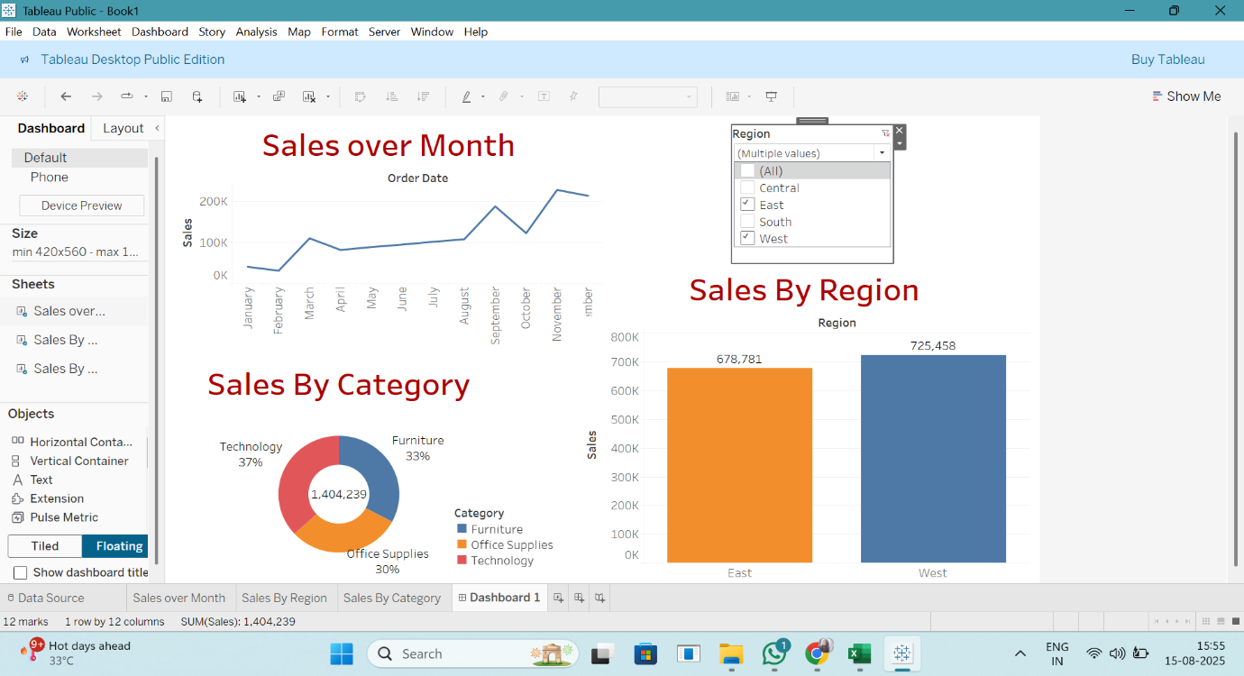

Dashboard Insights

1. Monthly Sales Trend  
   The line chart shows a general upward trend in sales, with notable peaks around March, September, and November. This indicates strong seasonal performance—perhaps tied to promotional periods or end-of-quarter purchases. Focusing marketing campaigns in these high-performing months could boost results even further.
2. Regional Performance Comparison  
   In the bar chart, the West region outperforms the East, suggesting it’s your top-performing region. Given that only East and West are displayed, consider investigating Central and South (via the slicer) to understand if they offer untapped potential or are dragging overall performance.
3. Category Contribution to Total Sales  
   The donut chart reveals that Technology holds the largest share at approximately 37%, followed by Furniture (33%) and Office Supplies (30%). Leveraging this strength, you could introduce more tech-focused offerings or bundles to capitalize on this dominating category.
4. Total Sales Emphasis  
   The center of the donut chart prominently displays the total sales (₹1,404,239). This acts as a powerful KPI—great for immediately conveying the dashboard’s scale and impact. It also helps users quickly assess how regional or category changes affect the overarching sales figure.

3. Based on the image showing a filtered view (Region slicer selecting *Central* and *South* only), here are four refined insights tailored to this scenario:

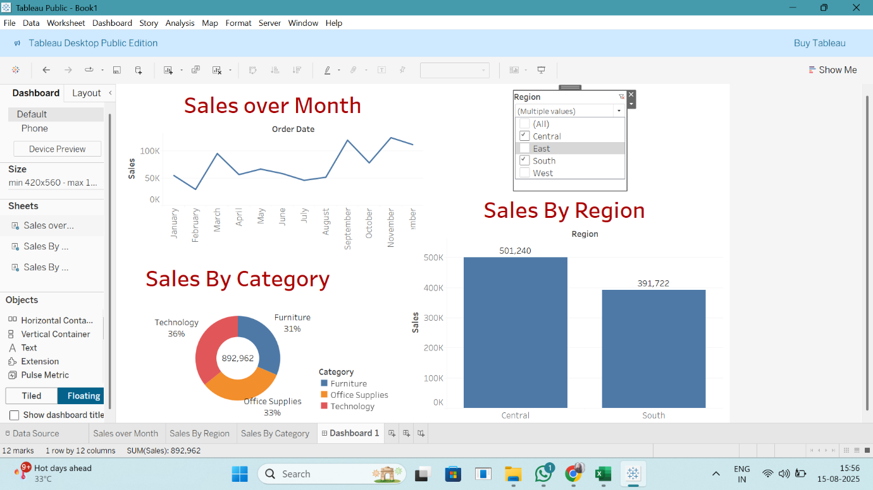

Dashboard Insights (Filtered: Central & South Regions)

1. Filtered Sales Trend (Central & South Only)  
   The line chart still shows an upward trajectory in sales, although the absolute values are lower compared to the complete dataset. Sales appear to ramp up around September and November, suggesting similar seasonal behavior even when limited to Central and South regions.
2. Regional Sales Comparison  
   In the Sales by Region bar chart, the Central region (₹392K)—a clear indication that Central contributes more to sales in this subset.
3. Consistent Category Distribution  
   The donut chart shows a nearly even split among categories in these regions:
   * Technology: ~36%
   * Office Supplies: ~33%
   * Furniture: ~31%  
     This suggests that, despite filtering regions, the product mix remains balanced, with Technology having a slight advantage.
4. Total Sales Context (Filtered Data)  
   The donut’s center KPI indicates total sales of ₹892,962 in just these two regions. This view emphasizes the importance of filtering and shows how region selection can significantly impact overall performance metrics.
5. Sales over Month (line chart), Sales by Region (bar chart showing East and South), and Sales by Category (donut chart) are displayed, with the filter set to East and South regions.

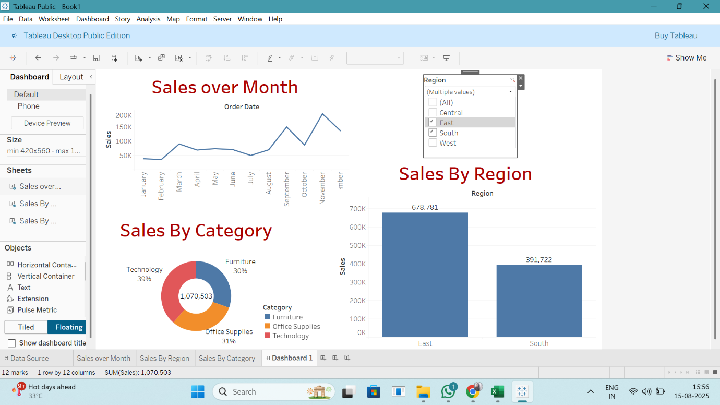

Dashboard Insights (Filtered: East & South Regions)

1. Seasonal Trends Persist Regionally  
   The line chart continues to show consistent seasonal peaks in September and November, even when focusing solely on the East and South regions. This suggests that promotional or demand cycles are synchronized across these regions.
2. Regional Sales Disparity  
   In the Sales by Region bar chart, the East region posts significantly higher sales (₹392K). This indicates that East is a stronger market, suggesting tailored growth strategies could help bolster sales in the South.
3. Category Distribution Remains Balanced  
   The donut chart reveals a nearly even share among product categories: Technology ~39%, Office Supplies 31%, and Furniture 30%. This indicates uniform demand across categories in these two regions, with Technology holding a slight lead.
4. Filtered Sales KPI  
   The center of the donut displays the combined total sales for East and South—₹1,070,503. This spotlighting of filtered totals underscores how regional segmentation can significantly shift performance metrics and visual insight.